Press Release

Royole Moon 3D Virtual Mobile Theatre at IFA 2017

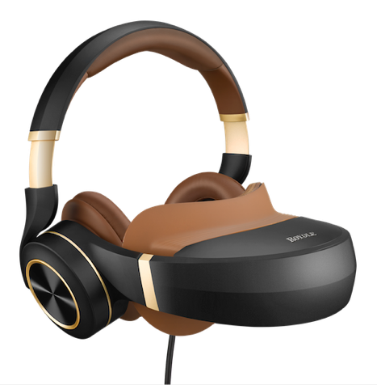
Berlin 2018 – Royole Corporation, a leading innovator and manufacturer of next-generation human-machine interface technologies and products such as advanced flexible displays, flexible sensors, and smart devices, today announced that it will be at IFA 2017 showcasing its new foldable 3D Virtual Mobile Theatre, the Royole Moon (Hall 11.1, Stand 135), as they expand throughout Europe.
At a glance…

Category:

Theme:
3D Virtual Mobile Theatre: Royole Moon comes to Europe to the IFA.

Website:
http://www.royole.com/

Facts:
- Portable 3D-Entertainment-System
- 2x Full-HD (1.080p) AMOLED
- Giant Curved Screen
- Active Noise Reduction
- Foldable Design
- Battery lasts for 5 hours
- Limitless 2D-/3D-Content
- RRP: TBC
- IFA, Hall 11.1, Stand 135

Press Contact:
Ranieri
Lauren Crimp
Ground Floor, 2 Eastbourne Terrace, London, W2 6LG

Tel. 0207 148 1606
Email. laurenc@raniericoms.com

Royole Corporation
Michael Williams
48025 Fremont Blvd
Freemont, CA 94538
USA
Tel. +1 510/ 490 1601
michael.williams@royole.com

The Royole Moon’s immersive technology creates a cinematic experience that transports users straight into the action of a blockbuster movie, videogame or music, but in a personal, mobile environment. While viewing through Moon, users get the experience of a giant, scalable curved screen with realistic 3D-effects all generated through unrivaled, proprietary optical system technologies. With active noise-cancelling headphones, Moon allows for a truly immersive entertainment experience so that users can easily find themselves lost in the drama of their movie or game. Royole Moon features two AMOLED-displays, providing a sensory busting 3000ppi and 1080p resolution for each eye, so users come as close as possible to the experience of sitting in their own private movie theatre.
3D experience on gigantic curved screen
As pioneers in display technology with hundreds of patents pending, Royole Corporation has developed Moon to feature two full 1080p HD displays with a pixel density of more than 3,000ppi. The integrated AMOLED technology with a contrast ratio of more than 10,000:1, coupled with a best-in-class colour spectrum promises users superior resolution and stunning image definition.

Royole‘s proprietary optical design allows for both screens to be adjusted individually with adjustments from -7.0 diopter nearsightedness to +2.0 diopter farsightedness for each eye. This means that users can enjoy Moon comfortably without the need for their prescription glasses.
Versatile compatibility, infinite content
With the Royole Moon 3D Virtual Mobile Theatre, you can play 2D and 3D content directly from your smartphone, tablet, set-top-box, computer or gaming consoles. In addition, its 32GB internal memory allows the user to take their content on-the-go. Moon can stream videos, blockbuster movies and games in all major formats and interfaces, including HDMI, USB on-the-go and Wi-Fi. Moon also features a new operating system called Moon OS to support online video, web browsing, music, APP download and installation at users’ will.
Entertainment with style
With a slim profile and stylish colourways in matte black, white and gold, the elegant Royole Moon not only provides entertainment at its best, but also creates a stunning visual impression. Its unique, foldable design saves on space and makes for the perfect travel companion, while its patented, leather padded ear cups provide a snug and comfortable fit. Additionally, the right earpad with flexible sensors acts as an intuitive touch control point for users to navigate content.
With a maximum operating time of five hours, the Royole Moon far outstrips the battery life of its competitors so whether it’s a movie or a full box-set, users can fully immerse themselves in their content.
Dr. Bill Liu, founder and CEO of Royole said:
“The technology we’ve been developing at Royole Corporation truly has people stopping in their tracks. Since we showcased Moon at CES 2017, we’ve had the opportunity to fine-tune it and are delighted to introduce our very latest edition at IFA 2017 as well as make our Virtual 3D Home Theatre available in Europe for the very first time.”
Price and availability
The Royole Moon is available from Amazon.com at an RRP of £849.99.
Royole’s IFA showcase
The Moon 3D Virtual Mobile Theatre will be showcased with gaming and theatre demonstrations.

In addition to Moon, Royole Corporation will also demonstrate a whole host of products utilising its groundbreaking flexible display (the world’s thinnest full colour display, approx. 0.01mm), and flexible sensor technologies. Included on the stand will be Royole’s FlexPhone, world’s first curved car dashboard featuring flexible sensors, award winning smart cycling backpack, and other innovative smart devices that utilize Royole’s proprietary technologies.

About Royole
Founded by Stanford engineering graduates in 2012, Royole’s mission is to improve the way people interact with and perceive their world. The company creates and manufactures next-generation human machine interface technologies and products including advanced flexible displays, flexible sensors, and smart devices. Technology milestones include the world's thinnest full-color AMOLED flexible display and flexible sensors (2014), the world's first foldable 3D virtual mobile theater (2015), and the world's first curved car dashboard based on flexible electronics (2016).

Royole has received numerous global awards for its technology innovations and fast growth. Holding over 1200 IPs, it also provides IP licenses, services, and, mass production and solutions for flexible electronics applications. Royole, backed by leaders in global finance, has announced a new 1.1-million-square-foot flexible display production campus in Shenzhen, China with a total investment of USD $1.7B to be fully operational by Q4 2017. Royole has offices in Fremont, CA, Hong Kong, and Shenzhen, China. For more information, please visit: www.royole.com.

Further queries:
Lauren Crimp
Senior Account Executive

Phone: 0207 148 1606
Email: laurenc@raniericoms.com
Web: www.raniericommunications.com
Ranieri, Ground Floor, 2 Eastbourne Terrace, London, W2 6LG

